Week 4 – Initial System Configuration & Security Implementation
1. Secure Shell (SSH) Configuration with Key-Based Authentication
Objective
The purpose of this assignment was to strengthen the security of the Ubuntu Server's remote access by setting up SSH key-based authentication and turning off password-based login. This measure will effectively lower the chances of brute-force attacks and unauthorized access.
SSH Key Generation
Machine: Ubuntu Desktop Workstation
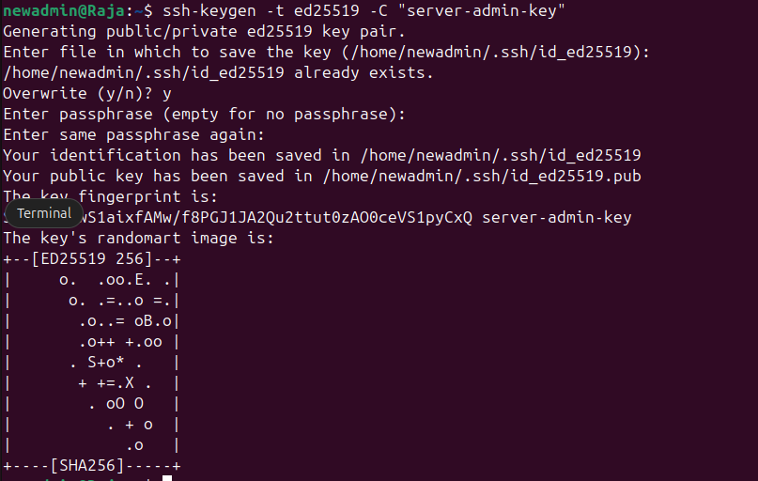
Comment (Workstation):
A public/private key pair is thus generated that allows secure server authentication. The private key stays on the workstation, whereas the public key will be transferred to the server.
Copying Public Key to Server
Machine: Workstation (SSH client)
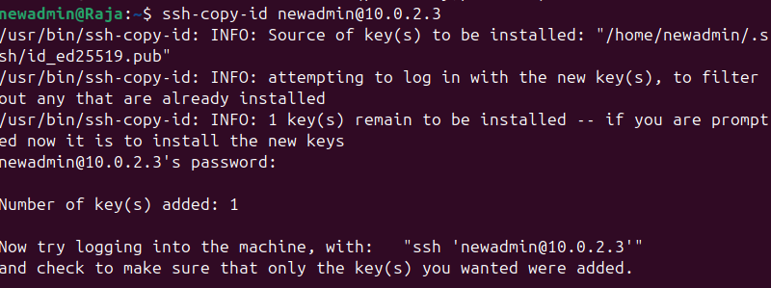
Comment (Server)
Public key is installed on adminuser in the Ubuntu Server user account thus enabling password less key-based authentication.
SSH Configuration Hardening (Server)
Machine: Ubuntu Server (via SSH)
sudo nano /etc/ssh/sshd_config
Configuration Changes
Before:
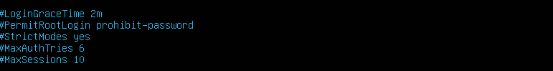
After:
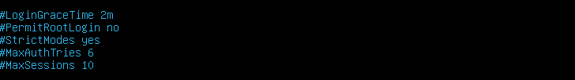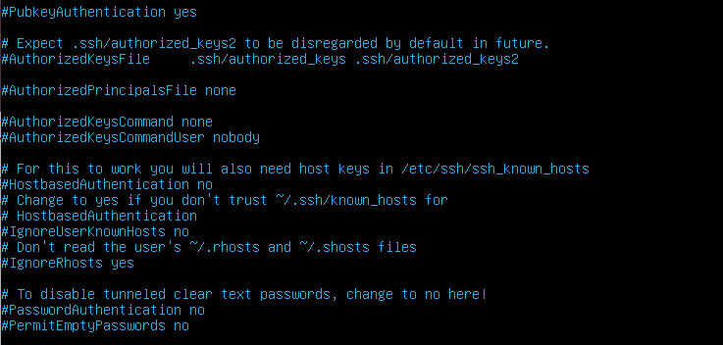
Comment (Server):
Authentication using keys only is the single method for allowing access, thus enhancing security because password-based login and root login are turned off.
Restart SSH Service
Machine: Ubuntu Server (via SSH)
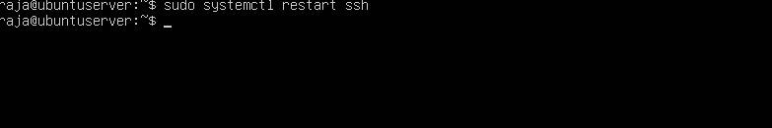
Comment (Server)
It is the case that modifications to the sshd_config file become effective only upon restarting the SSH service. The server has been secured for key-based SSH access now.
2. User Management and Privilege Configuration
Objective
A non-root admin user has been created and granted the right to use sudo as per the principle of least privilege.
Creating a Non-Root Administrative User
Machine: Server (via SSH)
Commands:
sudo adduser adminuser
sudo usermod -aG sudo adminuser
Comment (Server):
A non-root user with the name newadmin has been created and assigned to the sudo group so that he could perform administrative operations without logging in as the root user. This is in line with the secure system administration practices.
Verifying Sudo Access
Machine: Ubuntu Server (via SSH)
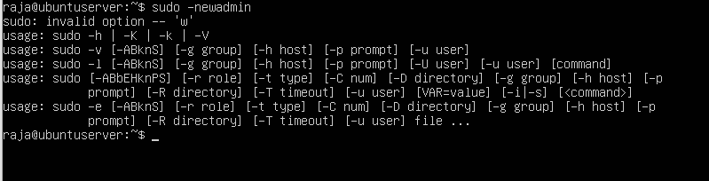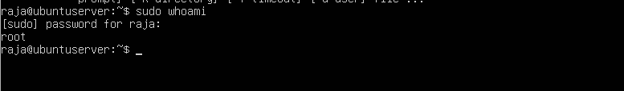
Comment (Server):
The verification of sudo access shows that adminuser possesses the necessary administrative rights without the requirement of direct root login, which is in line with the principle of least privilege.
3. Firewall Configuration (Restricted SSH Access)
Objective
To limit network access to the server, the firewall is configured to allow only SSH traffic from the 'trusted' workstation IP address.
Enabling UFW Firewall
Machine: Server (via SSH)
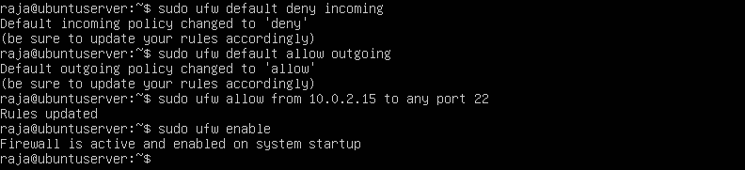
Remark:
- By default, all incoming traffic gets blocked, while outgoing traffic is permitted.
- SSH access is limited to one IP (10.0.2.15), so the only connection possible is from a workstation that has been trusted.
- UFW activation imposes these rules, thereby enhancing the server’s security in total.
Firewall Rules Verification
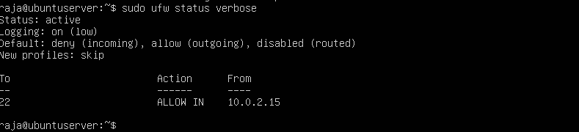
Comment:
- The listing of all the rules that are currently active in the firewall is the output of this command.
- Moreover, it verifies that the SSH connection is limited to the specified workstation's IP address.
4. SSH Access Evidence (Mandatory)
Objective:
To demonstrate that password-based login is off whereas SSH key authentication is correctly working.
Successful SSH Login Using Keys
Machine: Workstation
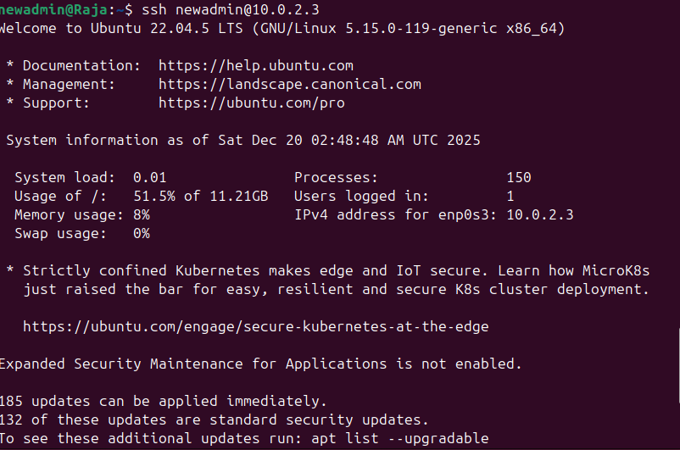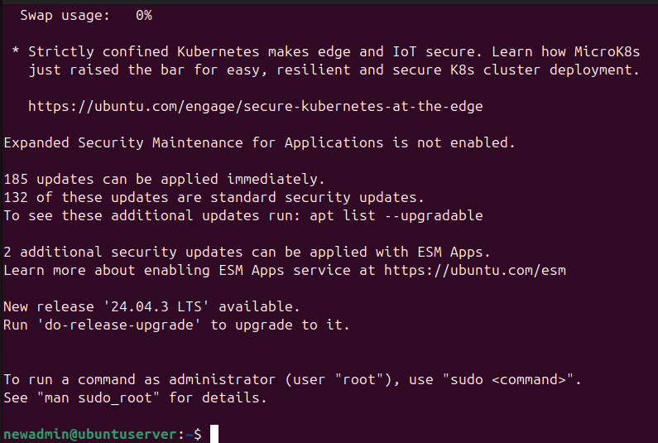
Comment:
- The private key of the workstation is utilized in this SSH connection for the authentication of the newadmin on the Ubuntu server.
- The server has disabled password authentication which means only key-based login is allowed.
- The login that was successful is evidence that the server hardening measures for SSH were properly applied.
SSH Configuration Summary
Setting | Before | After
Root Login | Enabled | Disabled
Password Authentication | Enabled | Disabled
Key-Based Authentication | Disabled | Enabled
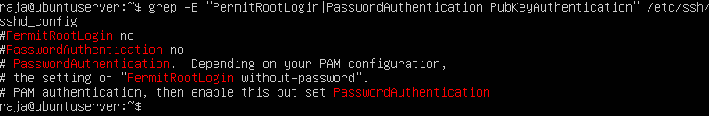
6.Remote Administration Evidence
Objective:
In order to provide evidence that any and all system administration activities took place remotely through SSH from the workstation, thus proving that key-based authentication is operational and that administrative actions are securely performed.
Evidence of Remote Configuration via SSH
Machine: Workstation → Server (via SSH)
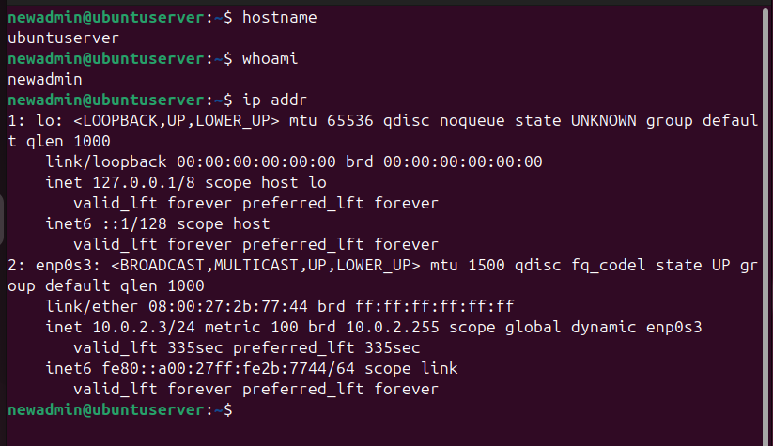
Comment:
- The given commands are proof that the workstation made a successful SSH connection to the server.
- Remote access was used to carry out all the administrative tasks without any requirement for actual physical access.
- The results are confirming that the user context (newadmin) as well as the network configuration of the server are in line with the expectation.
Conclusion
During Week 4, basic security controls were put into practice on the Ubuntu Server system. Secure SSH access was set up with key-based authentication, and password login was turned off. A non-root admin user was created to maintain privilege separation, and a firewall was set up to allow SSH access only from the trusted workstation. All these configurations were applied remotely through SSH, thus meeting the constraints of the coursework regarding administration. The system attack surface has been greatly reduced by these measures and a secure baseline for advanced security controls, which will be implemented in the following weeks, has been established.

